Building and Publishing ASP.NET Applications with Microsoft Azure Websites

Overview
Web site publication and deployment has never been easier in Microsoft Azure. Using familiar tools such as Web Deploy or Git, and virtually no changes to the development workflow, Microsoft Azure Websites is the next step in the Microsoft Azure platform for web developers.
In this hands-on lab, you will explore the basic elements of the Microsoft Azure Websites service by creating a simple ASP.NET MVC 5 application, which uses scaffolding to automatically generate the baseline of your application's CRUD (Create, Read, Update and Delete). Then, you will deploy it using Web Deploy from Microsoft Visual Studio 2013.
Starting from a simple model class and without writing a single line of code, you will create a controller that will contain all the CRUD operations, as well as all the necessary views. After publishing and running the solution, you will have the application database generated in your SQL Database server, together with the MVC logic and views for data manipulation.

Objectives
In this hands-on lab, you will learn how to:
Create a Web Site from the Microsoft Azure Management Portal
Use Microsoft Visual Studio 2012 to build a new ASP.NET MVC 5 application
Deploy the application using Web Deploy from Visual Studio
Create a new Web Site with Git Repository enabled to publish the ASP.NET MVC 4 application using Git

Prerequisites
The following is required to complete this hands-on lab:
Microsoft Visual Studio 2013
GIT Version Control System
A Microsoft Azure subscription
In order to execute the exercises in this hands-on lab you need to set up your environment. Open a Windows Explorer window and browse to the lab's Source folder. Right-click the Setup.cmd file and click Run as administrator. This will launch the setup process that will configure your environment and check the dependencies.
Note: Make sure you have checked all the dependencies for this lab before running the setup.

Exercises
This hands-on lab includes the following exercises:
Exercise 1: Creating an MVC 5 Application using Entity Framework Code First
Exercise 2: Publishing an MVC 5 Application using Web Deploy
Exercise 3: Publishing an MVC 5 Application using Git

Exercise 1: Creating an MVC 5 Application using Entity Framework Code First
In this section, you will create a simple ASP.NET MVC 5 web application, using MVC 5 scaffolding with Entity Framework code first to create the CRUD methods.

Task 1 – Creating an ASP.NET MVC 5 Application in Visual Studio
Open Microsoft Visual Studio 2013 and click the New Project link in the start page. Otherwise use File | New | Project.
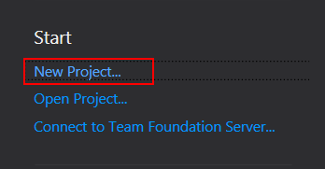
Create a new ASP.NET Web Application using .NET Framework 4.5, C# and name it MVCSample.Web.
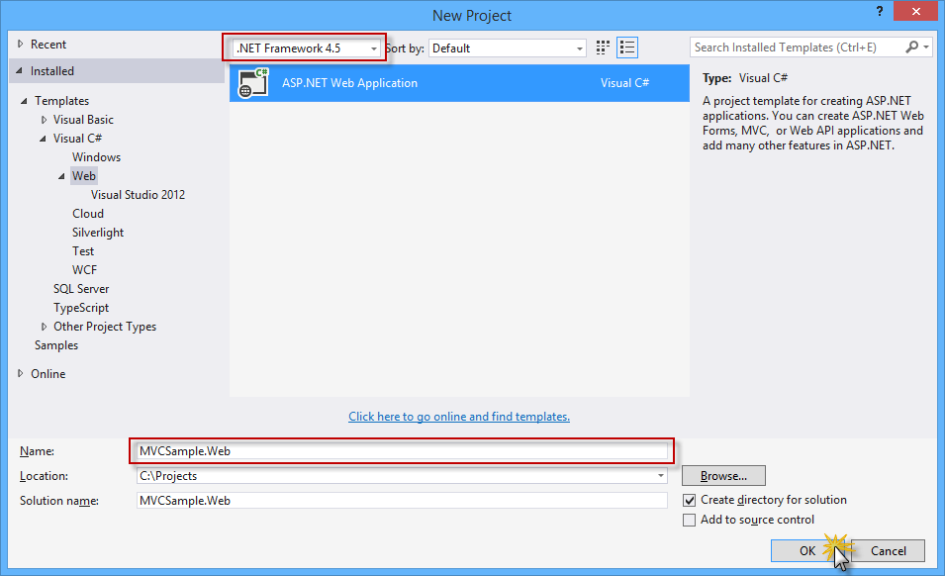
Select the MVC template and make sure that Authentication is set to Individual User Accounts. Click OK to continue.
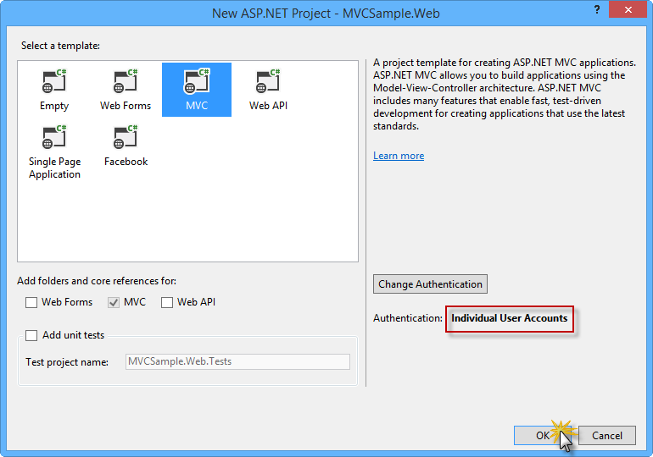
In the Solution Explorer, right-click Models and select Add | Class to create a customer class (POCO). Name it Customer.cs and click Add.
Open the Customer class and insert the following properties.
using System;
using System.Collections.Generic;
using System.Linq;
using System.Web;

namespace MVC4Sample.Web.Models
{
public class Customer
{
public int CustomerId { get; set; }

public string Name { get; set; }

public string Phone { get; set; }

public string Address { get; set; }

public string Company { get; set; }

public string Title { get; set; }

public string Email { get; set; }

public string Image { get; set; }
}
}
Build MVCSample.Web by using the Ctrl + Shift + B keyboard shortcut which will save the changes and build the project.
In Solution Explorer, right-click the Controllers folder and select Add | Controller....
In the Add Scaffold dialog box, select the MVC 5 Controller with views, using Entity Framework scaffolding type and click Add.
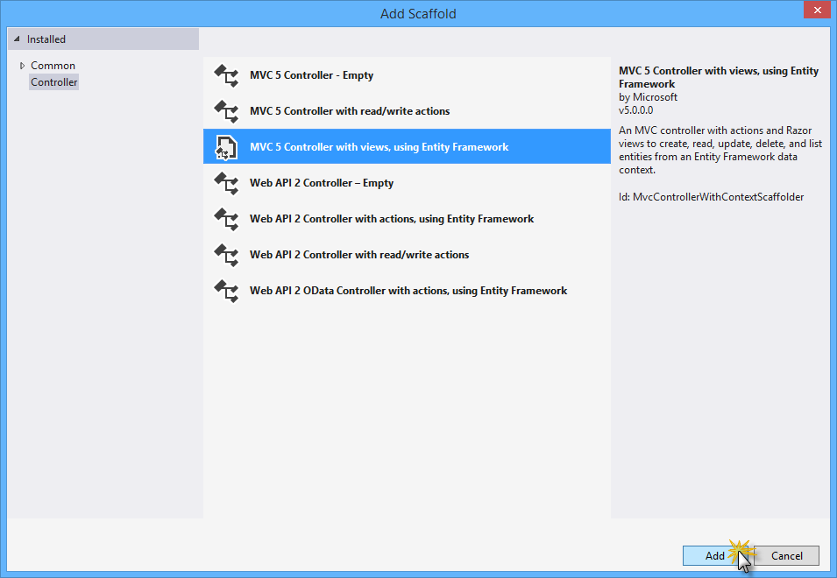
Name the controller CustomerController and complete the Scaffolding options with the following values.
In the Controller name box, type CustomerController.
Select the Use async controller actions checkbox.
In the Model class drop-down list, select the Customer class.
In the Data Context class field, click <New data context...>. In the dialog box displayed, replace the data context class type with MVCSample.Web.Models.CustomerContext and click OK.
In the Views section, make sure that all checkboxes are selected.

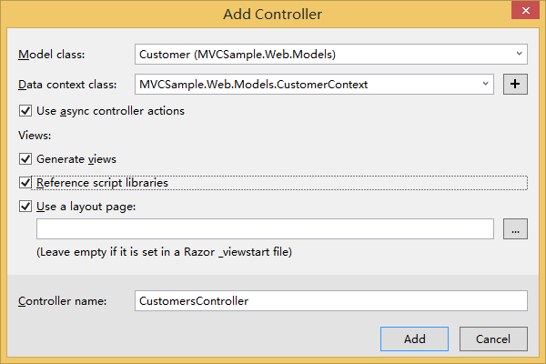
Click Add to create the new controller for Customer with scaffolding. You have generated the controller actions as well as the views.
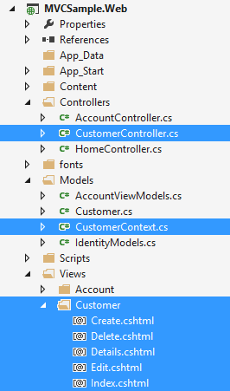
Open the CustomerController.cs file in the Controllers folder. Notice that the CRUD action methods have been generated automatically.
Note: By selecting the Use async controller actions checkbox from the scaffolding options in the previous steps, Visual Studio generates asynchronous action methods for all actions that involve access to the Customer data context. It is recommended to use asynchronous action methods for long-running, non-CPU bound requests to avoid blocking the Web server from performing work while the request is being processed.

// POST: /Customer/Create
// To protect from overposting attacks, please enable the specific properties you want to bind to, for
// more details see http://go.microsoft.com/fwlink/?LinkId=317598.
[HttpPost]
[ValidateAntiForgeryToken]
public async Task<ActionResult> Create([Bind(Include="CustomerId,Name,Phone,Address,Company,Title,Email,Image")] Customer customer)
{
if (ModelState.IsValid)
{
db.Customers.Add(customer);
await db.SaveChangesAsync();
return RedirectToAction("Index");
}

return View(customer);
}

// GET: /Customer/Edit/5
public async Task<ActionResult> Edit(int? id)
{
if (id == null)
{
return new HttpStatusCodeResult(HttpStatusCode.BadRequest);
}
Customer customer = await db.Customers.FindAsync(id);
if (customer == null)
{
return HttpNotFound();
}
return View(customer);
}

...

Exercise 2: Publishing an MVC 5 Application using Web Deploy
In this exercise, you will create a new web site in the Microsoft Azure Management Portal and publish the application you obtained in the Getting Started section, taking advantage of the Web Deploy publishing feature provided by Microsoft Azure.

Task 1 – Creating a New Web Site from the Microsoft Azure Portal
Go to the Microsoft Azure Management Portal (Global: http://manage.windowsazure.com ; Mooncake: http://manage.windowsazure.cn) and sign in using the Microsoft credentials associated with your subscription.
Click New on the command bar.

Click Compute, Web Site and then Quick Create. Provide an available URL for the new web site and click Create Web Site.
Note: A Microsoft Azure Web Site is the host for a web application running in the cloud that you can control and manage. The Quick Create option allows you to deploy a completed web application to the Microsoft Azure Web Site from outside the portal. It does not include steps for setting up a database.
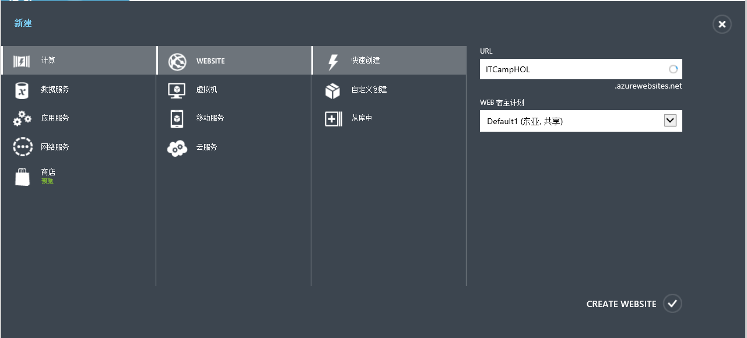
Note: By default, Microsoft Azure provides domains at azurewebsites.net (Mooncake: chinacloudsites.cn), but also gives you the possibility to set custom domains using the Microsoft Azure Management Portal. However, you can only manage custom domains if you are using certain Web Site modes.
Microsoft Azure offers 3 modes for users to run their Websites - Free, Shared, and Reserved. In Free and Shared mode, all Websites run in a multi-tenant environment and have quotas for CPU, Memory, and Network usage. You can mix and match which sites are Free (strict quotas) vs. Shared (more relaxed quotas). The maximum number of free sites may vary with your plan. The Reserved mode applies to ALL of your sites and makes them run on dedicated virtual machines that correspond to the standard Azure compute resources. You can find the Websites Mode configuration in the Scale menu of your Web Site.
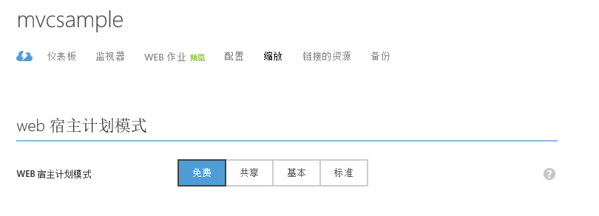
If you are using Shared or Reserved mode, you will be able to manage custom domains for your Web Site. To do so, go to the Configure menu of your Web Site and under domain names click Manage Domains.
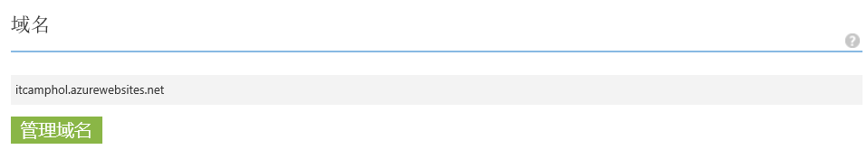
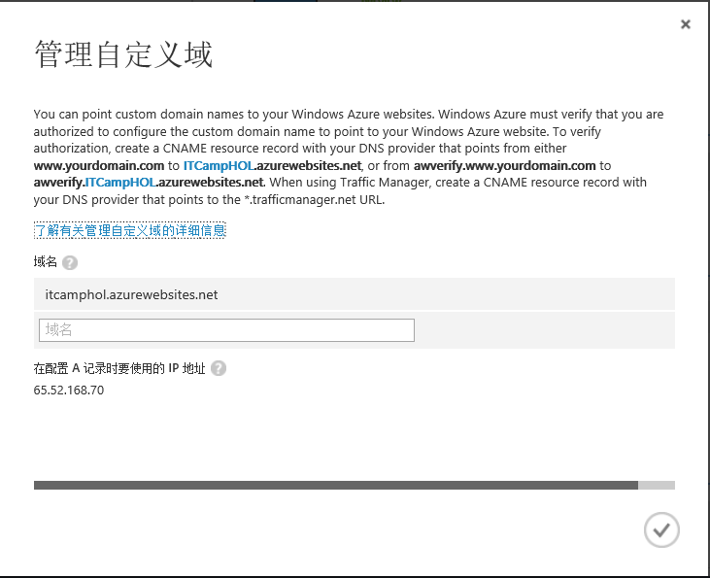
Once the Web Site is created, click the link under the URL column. Check that the new Web Site is working.
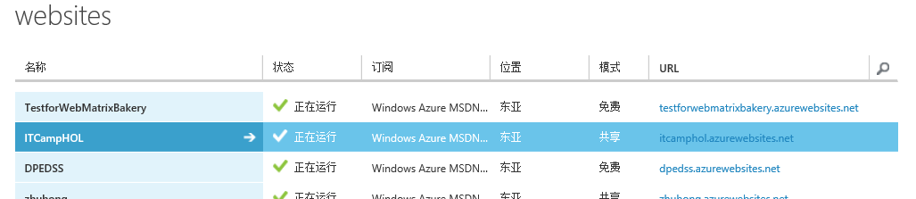
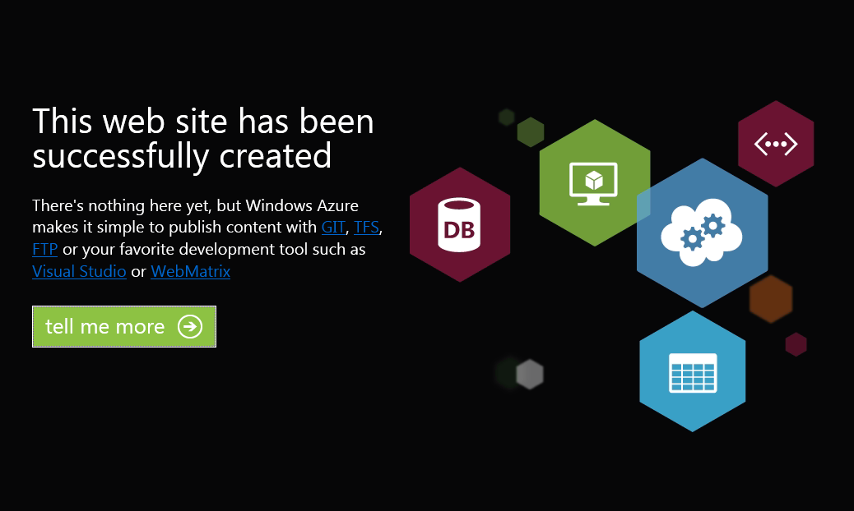

Task 2 – Configuring the Database Server
You will need a SQL Database server for storing the application database. You can view the SQL Database servers from your subscription in the portal at Sql Databases | Servers. If you do not have a server created, you can create one using the Add button at the bottom of the page. Make note of the server NAME, MANAGE URL, and ADMINISTRATOR LOGIN, and obtain the server's password, which is not shown in the portal. You will use this information next. Do not create the database yet, as it will be created by Entity Framework when running the application.
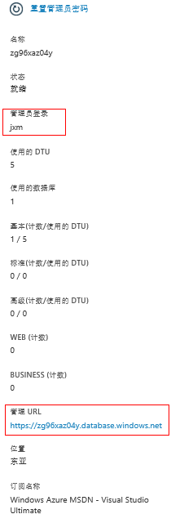
In the next task, you will test the database connection from Visual Studio. For that reason, you need to include your local IP address in the server's list of Allowed IP Addresses. To do that, click Configure, and then click the button next to the IP address labeled CURRENT CLIENT IP ADDRESS.
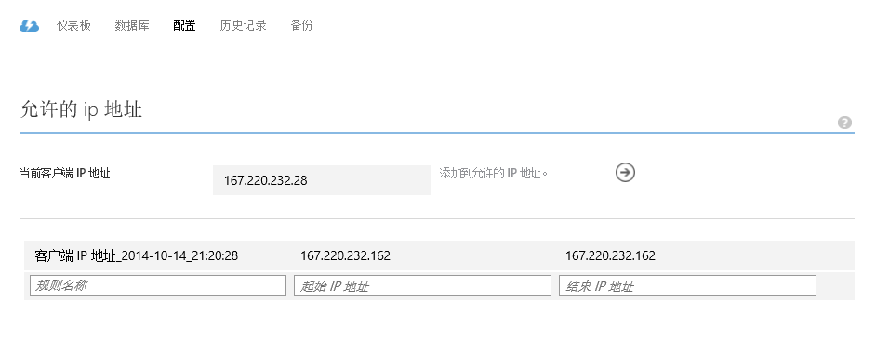
Once the Client IP Address is added to the allowed IP addresses list, click Save to confirm the changes.
If the Web Site needs to link to a SQL database, the link configuration should be done first. Click the linked resource in the Web Site page.
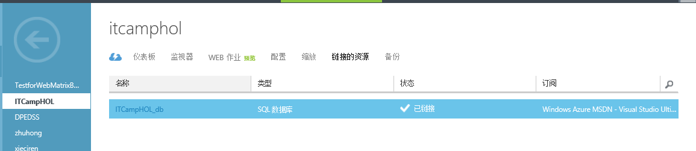
Click Link at the bottom, and click Create a new resource. Then you can enter its name and choose the server created (Note: the server should be verified using name and password first.). Click OK and then you can see the new created linked SQL database.
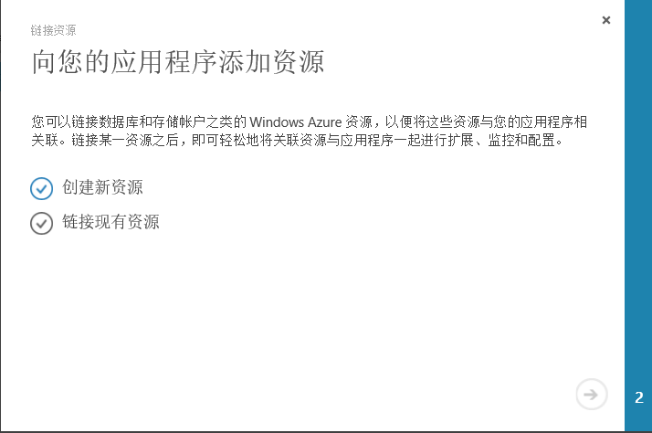
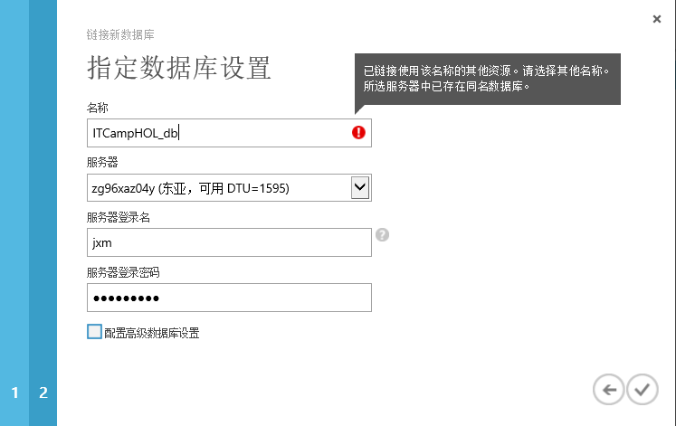

Go back to the portal and click the name of the web site under the Name column to display the management pages.
In the Dashboard page, under the quick glance section, click the Download the publish profile link.
Note: The publish profile contains all of the information required to publish a web application to a Microsoft Azure website for each enabled publication method. The publish profile contains the URLs, user credentials and database strings required to connect to and authenticate against each of the endpoints for which a publication method is enabled. Microsoft WebMatrix 3, Microsoft Visual Web Developer and Microsoft Visual Studio 2013 support reading publish profiles to automate configuration of these programs for publishing web applications to Microsoft Azure websites.
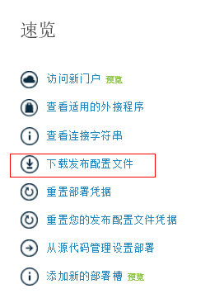
Download the publish profile file to a known location. Further in this exercise you will see how to use this file to publish a web application to a Microsoft Azure Websites from Visual Studio.
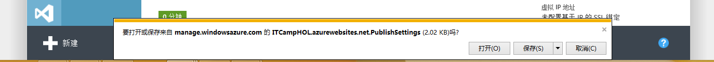

Task 3 – Publishing an ASP.NET MVC 5 Application using Web Deploy
Go back to the MVC 5 solution. In the Solution Explorer, right-click the web site project and select Publish.
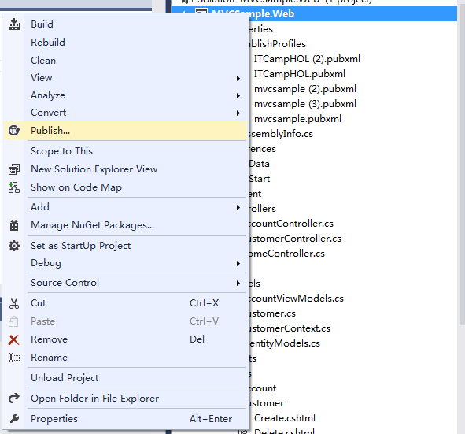
In the Profile page, click Import and select the profile settings file you downloaded earlier in this exercise.
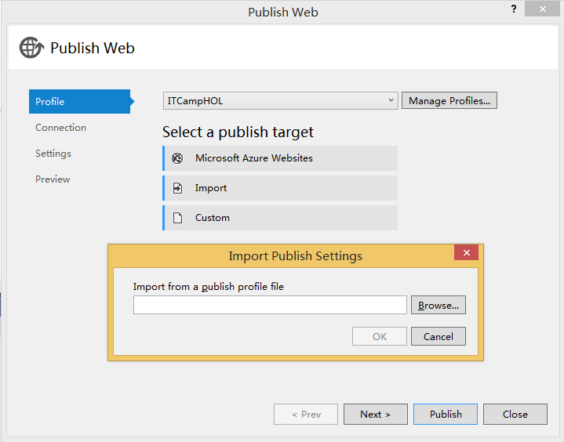
In the Connection page, leave the imported values and click Validate Connection. Once the validation is completed, click Next.
Note: Validation is completed once you see a green checkmark appearing next to the Validate Connection button.
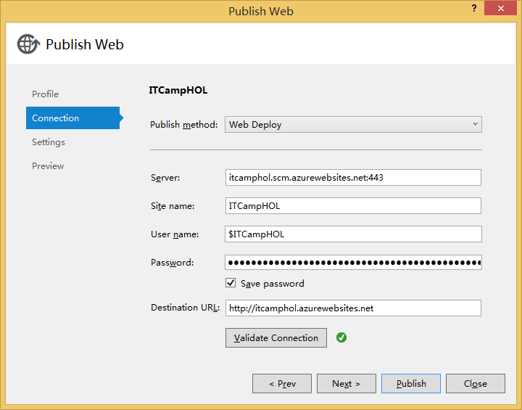
In the Settings page, under the Databases section, click the button next to the CustomerContext textbox. You can see the Database has already been linked to this Website.
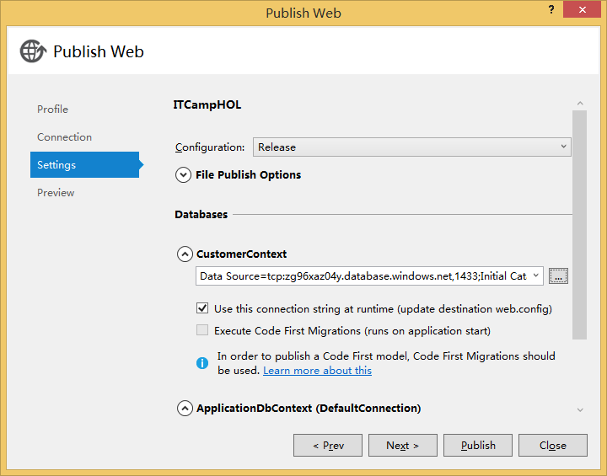
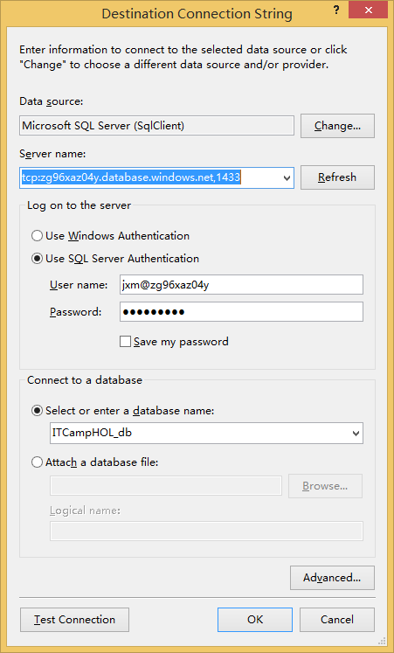
In the Preview page, click Publish.
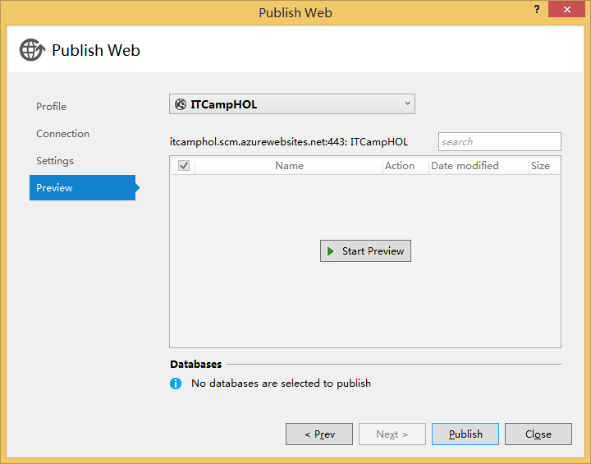
Once the publishing process finishes, your default browser will open the published web site. Verify that the web site was successfully published in Microsoft Azure.
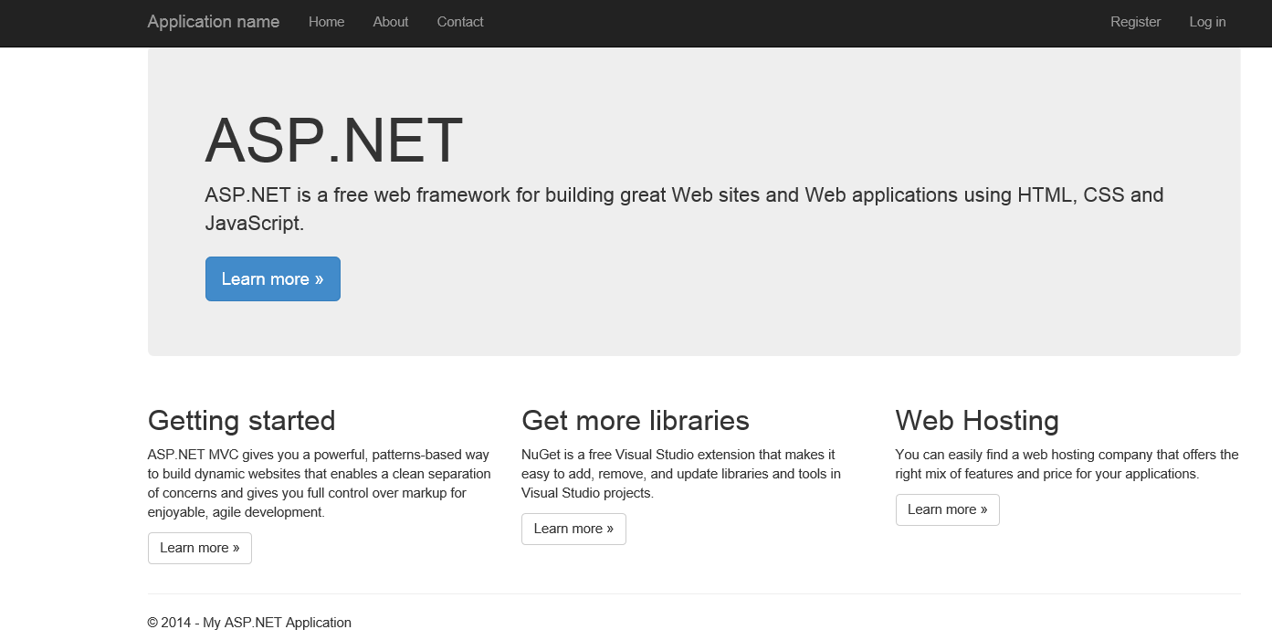
Go to /Customer to verify that the Customers views are working as expected. You can try adding a new Customer to verify it is successfully saved to the database.
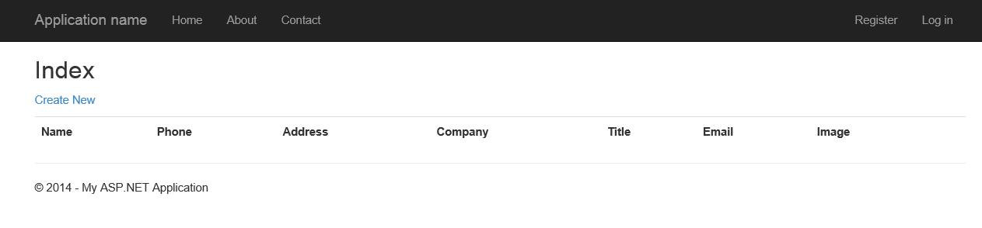

Exercise 3: Publishing an MVC 5 Application using Git
In this exercise you will publish again the web application you created in exercise 1, but this time using Git.

Task 1 – Setting up Git Publishing
Go back to the Microsoft Azure Management Portal. In the Websites section, locate the web site you created in the previous exercise and open its dashboard. To do this, click the web site's Name.
Under the quick glance section, click Set up deployment from source control link.
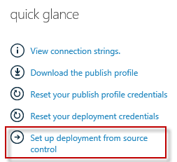
Once the Set up Deployment window is displayed, select Local Git repository and click Next.
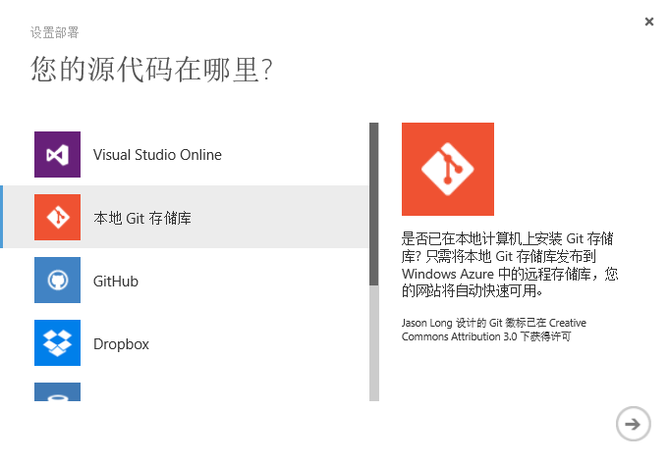
A message indicating that your Git repository is being created will appear.
Note: You may be prompted for username and password.
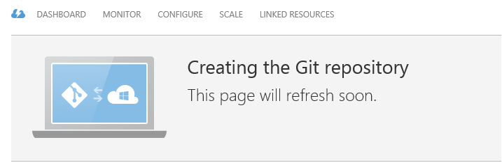
Wait until your Git repository is ready to use before continue with the following task.
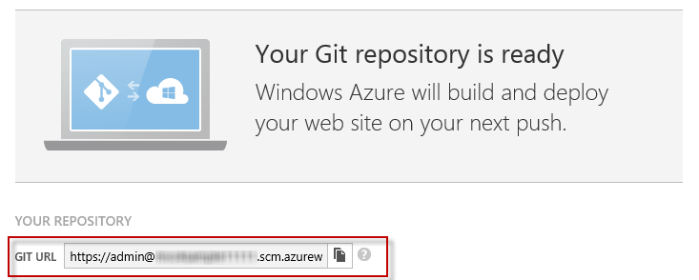
Copy the Git URL value. You will use it later in this exercise.

Task 2 – Pushing the Application to Microsoft Azure using Git
Open the solution you have obtained in exercise 1 with Visual Studio. Press CTRL+SHIFT+B to build the solution and download the NuGet package dependencies.Open Web.config and update the CustomerContext connection string using the one obtained from Portal.
Web Site -> Dashboard -> Connection String(right side of the web page).
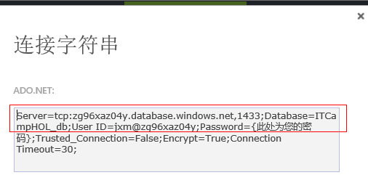
You can see the detailed connection string in this box. Modify the web.config file like below and replace the placeholders according the connection string above.
<connectionStrings>
...
<add name="CustomerContext" connectionString="Data Source=tcp:{SERVER_URL};Initial Catalog=MVCSample_db;User ID={SERVER_ADMIN_LOGIN};Password={PASSWORD}"
providerName="System.Data.SqlClient" />
</connectionStrings>

Open a new Git Bash console and insert the following commands. Update the [YOUR-APPLICATION-PATH] placeholder with the path of the MVC solution you've created in Exercise 1.
cd "[YOUR-APPLICATION-PATH]"
git init
git add .
git commit -m "Initial commit"
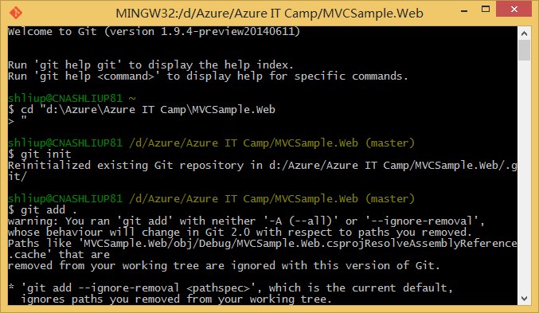
Push your web site to the remote Git repository by running the following command. Replace the placeholder with the URL you obtained from the Microsoft Azure Management Portal. You will be prompted for your deployment password.
git remote add azure [GIT-CLONE-URL]
git push azure master
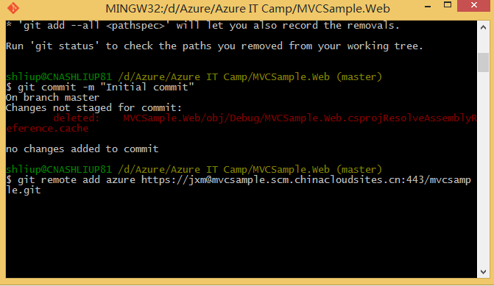
Note: When you deploy content to the FTP host or GIT repository of a Microsoft Azure website you must authenticate using deployment credentials that you create from the website’s Quick Start or Dashboard management pages. If you don't know your deployment credentials you can easily reset them using the management portal. Open the web site Dashboard page and click the Reset your deployment credentials link. Provide a new password and click OK. Deployment credentials are valid for use with all Microsoft Azure websites associated with your subscription.
In order to verify the web site was successfully pushed to Microsoft Azure, go back to the Microsoft Azure Management Portal and click Websites.
Locate your Web Site (where you deployed the application) and click its Name to see the Dashboard.
Click Deployments to see the deployment history. Verify that there is an Active Deployment with your "Initial Commit".
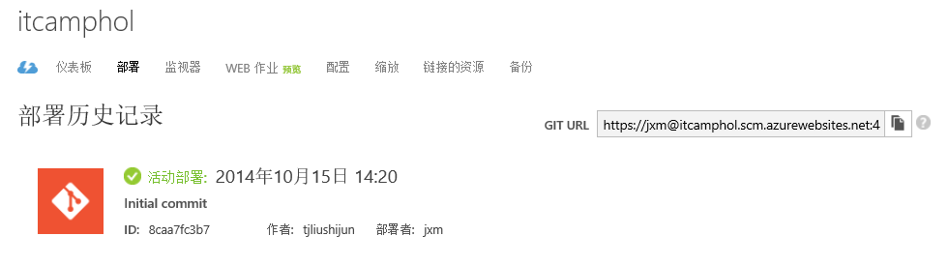
Finally, click Browse on the bottom bar to go to the web site.
If the application was successfully deployed, you will see the ASP.NET MVC 5 template's default home page.
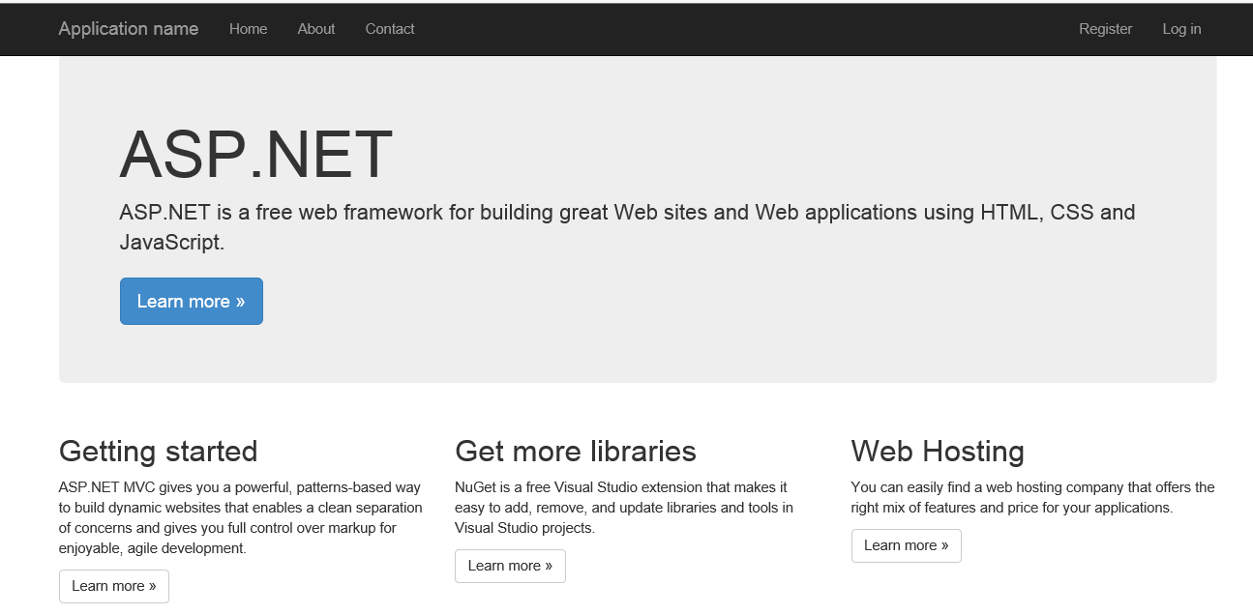
Go to /Customer to verify that the Customers views are working as expected. You can try adding a new Customer to verify it is successfully saved to the database.

Summary
In this hands-on lab, you have created a new MVC web site using MVC 5 Scaffolding and published it to Microsoft Azure Websites. Web site publication and deployment has never been easier in Microsoft Azure. Using familiar tools such as Web Deploy or Git, and virtually no changes to the development workflow, Microsoft Azure Websites is the next step in the Microsoft Azure platform for web developers.

